First River Farms (FRF) HOA
Resale Instructions

Order the resale document from the SCS website. See below for detailed instructions.
- Visit the website at www.scs-management.com
- Click on orange wording at the top of the webpage – Order Resale Documents
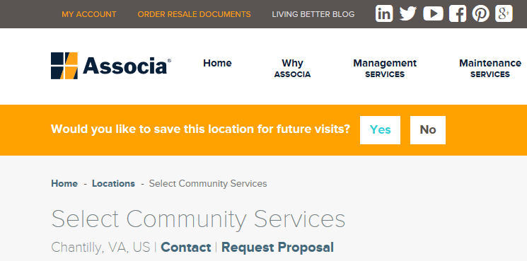
- Choose Select Community Services from list of companies

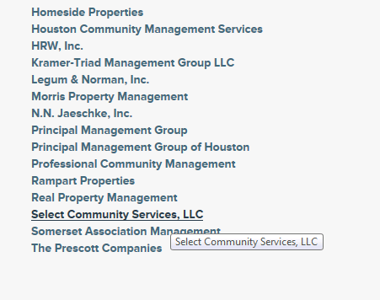

- If you have never ordered documents before – choose First time user link on the left and register.

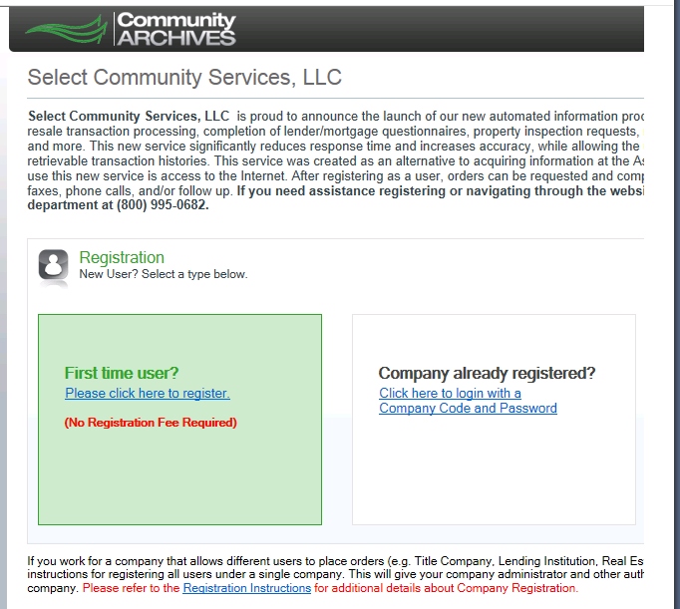

- Please make sure you order the correct documents. Below is a list of a few documents available.

First River Farms (FRF) HOA
Rules and Regulations
Resale Inspection Checklist
(To Be Completed by SCS)

FRF Townhouse Address: ___________________________________________________

Sale Inspection Date: ______________________________________________________

SCS Inspector Name: ______________________________________________________

Please place a check mark on the line if the townhouse property is in-compliance with the stated rule. If they are not in-compliance, place an asterisk (*) with your initial on the line and note the variance in the comments section on page 3. Each comment should reference the line item number from the list below.

Submit this completed FRF HOA Resale Inspection Checklist to the FRF HOA Board of Directors and allow them 3 business days to comment before proceeding with the sale process and sending a violation letter to the owner.

______ 1. Check to see if the townhouse has any outstanding violations. The owner of the townhouse needs to address all outstanding violations.

______ 2. Check to see if the townhouse owner is delinquent on their HOA fees. The owner of the townhouse needs to be current on their HOA fees.

______ 3. The exterior of the townhouse should be in good repair (i.e., no broken shutters, no rotting wood, no broken windows, missing or torn screens, no rusted or missing metal lining, no pealing or cracked paint on the doors, shutters or window muntins, etc.).

______ 4. The front door and shutters (front, back and side of house) must be the same color.

______ 5. The front door/shutter color must be different than their adjacent neighbor. If the color is the same as their adjacent neighbor, the homeowner that is selling must change their exterior color to be incompliance with 4-1.4j prior to the sale closing.

______ 6. The railings must be the same color as the front door/shutters or black.

______ 7. The storm door must be the same color as the front door/shutters or the trim/siding.

______ 8. The door trim, bays, gables, siding, fascia boards, gutters and downspouts must all be the same color; and must be a lighter color than the front door/shutters.

______ 9. Window trim must match the window color or the color of all other trim.

______ 10. Window frames and mutins must be white or off white. Wood muntins in original windows must match the color of the window/door trim.

______ 11. The front door, storm door, door trim, shutters, and other areas that are painted on the exterior part of the townhouse must be on the FRF HOA authorized color palette. Shutters and factory finished doors that are faded are not in compliance and must be painted the correct non-faded authorized color.

______ 12. If the front door is not original to the townhouse (6 panel wooden door with no windows), they should have a change design approval on file.

______ 13. Screen doors with scalloped designs or wrought iron trim must have a change design approval on file.

______ 14. Windows must be maintained in good repair, without cracks or missing panes of glass. Windows should have muntins.

______ 15. Windows boxes/planters are prohibited on all levels on the front of the townhouse and on the upper floor on the rear (and side) of the townhouse.

______ 16. The sidewalk and porch should be in good repair.

______ 17. The landscaping of the townhouse should be in good repair (i.e., no overgrown bushes, no missing bushes, no bald spots where the grass died, etc.).

______ 18. The trees on the townhouse property should be well maintained. There should be no dead branches in the trees and the tree limbs should not be encroaching on the common area sidewalks or touching the neighboring townhouse. There should be no tree stumps on the townhouse property. All tree stumps need to be grounded down and the area replanted with grass seeds.

______ 19. Fences should be in good repair. All fence boards should be in place and not broken. The height of the fence should be less than 5 feet and the hardware (to include numbers, hinges, and handles) should be black.

______ 20. Patio/French/Deck doors may be white or off white or painted the same authorized color as the trim.

______ 21. All decks should have an exterior change design approval on file.

______ 22. Sheds in the back yard must not be higher than one (1) foot above the standard height patio fence (5 feet). Sheds must be in good repair if visible.

______ 23. Awnings and other permanent exterior sunshades are not permitted. Sun umbrellas are permitted. Clotheslines are not permitted outside of the patio area or above the level of the patio fences.

______ 24. Cable TV wiring should be securely fastened to the townhouse and shielded from view.

______ 25. Antennas should be located in a place shielded from view from the street to the maximum extent possible. Antennas shall be neither larger nor installed higher than is necessary for reception of an acceptable-quality signal.

______ 26. Security grills, grates, gates, and other similar doors or window coverings are not permitted.

Notes on each non-compliant rule with corresponding line number identified. Please add additional sheets of paper if needed.

